**Mini Project Report on**



**SMART GARBAGE MONITORING SYSTEM using Arduino UNO**



**Submitted in partial fulfillment of the requirement for the award of the degree of**

**BACHELOR OF TECHNOLOGY**

**IN**

**COMPUTER SCIENCE & ENGINEERING**

**Submitted by:**

**Manav Chauhan** **2018919**

***Under the Mentorship of***

**Dr. Sachin Sharma**

**Professor**



**Department of Computer Science and Engineering**

**Graphic Era (Deemed to be University)**

**Dehradun, Uttarakhand**

**January-2024**

GEU logo

**CANDIDATE’S DECLARATION**

I hereby certify that the work which is being presented in the project report entitled **“SMART GARBAGE MONITORING SYSTEM using Arduino UNO”** in partial fulfillment of the requirements for the award of the Degree of Bachelor of Technology in Computer Science and Engineeringof the Graphic Era (Deemed to be University), Dehradun shall be carried out by the under the mentorship of **Dr. Sachin Sharma, Professor**, Department of Computer Science and Engineering, Graphic Era (Deemed to be University), Dehradun.

Name: University Roll no:

Manav Chauhan 2018919

**Table of Contents**

| **Chapter No.** | **Description** | **Page No.** |
| --- | --- | --- |
| Chapter 1 | Introduction | **1** |
| Chapter 2 | Literature Survey | **3** |
| Chapter 3 | Methodology | **5** |
| Chapter 4 | Result and Discussion | **7** |
| Chapter 5 | Conclusion and Future Work | **8** |
|  | References | **9** |

**Chapter 1**

**Introduction**

In the following sections, a brief introduction and the problem statement for the work has been included.

* 1. **Introduction**

With the development in technology and Internet of Things specifically, there has been a change in the way we do things. The problem that my project addresses is that of garbage accumulation at various locations in our city. Overflowing of garbage bins has been a problem that leads to foul smell, negatively affects the beauty of the surroundings and acts as a nesting place for pests.

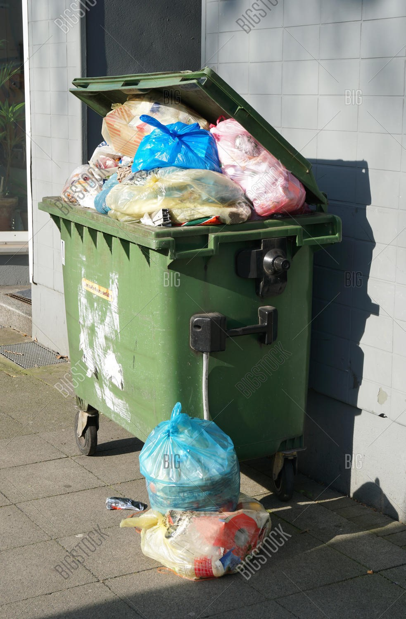

**Fig. 1.1 Overflowing garbage bin**

**1.2 Internet of Things (IoT)**

Leveraging the Internet of Things, we can design a smart garbage monitoring system. Internet of Things is essentially a network of physical devices that is connected through wires or without wires that has the ability to do communication with one another and also exchange data. This in turn improves the standard of living using the inter connected devices to achieve a specific task. This technology can be used in various sectors like water management, electricity management, traffic management, etc. In our scenario, it is used for garbage management. It aims to solve the issue of human intervention in such situations, where poor management and lack of concern for garbage has become a problem. Due to this inefficiency, waste accumulation in many areas is observed which can be solved using the power of IoT.



**Fig. 1.2 IoT**

**Chapter 2**

**Literature Survey**

Many researchers and academics are working on Smart Garbage Monitoring Systems using various methodologies, below are some literature studies:

**2.1 Smart Garbage Monitoring System Using Node MCU**

Mamatha Dhananjaya, Priyanka K.E, Nidhi.R, Pooja.K [1] proposed a smart bin that monitors the garbage bin and notifies users and also segregates the garbage when dumped into the bin. They used an Ultrasonic Sensor, PIR Sensor, Moisture Sensor, Arduino and NodeMCU. Their system also detects the presence of rodents and data collected is sent to the cloud which is then analyzed and proper notifications are sent.

**2.2 Smart Garbage Monitoring System using Internet of Things (IOT)**

Prof. Dr. Sandeep M. Chaware, Shriram Dighe, Akshay Joshi, Namrata Bajare, Rohini Korke [2] proposed a system which uses an Ultrasonic sensor, Arduino, LCD Screen, WiFI and a buzzer. The readings are displayed on an LCD screen and the buzzer goes off when the threshold limit is reached. When the bin is full, the GSM module sends a notification to the required authority.

**2.3 Garbage monitoring system using IoT**

Anitha A [3] proposed a Smart bin using an ultrasonic sensor, arduino, wifi module and an android app. The ultrasonic sensor detects when the bin is full and sends a signal to the android application using the WiFi module which notifies the user that the bin is full.

**2.4 Smart Garbage Monitoring and Segregation Process Using Arduino**

Vishnupriya M, Mohana priyanka K. and Malar R [4] proposed a system which uses an IR sensor, Arduino and a Robotic arm operated by servo motors. They used an IR sensor to check if the overfill condition was satisfied. They used a robotic arm to manually segregate the waste into biodegradable and non biodegradable wastes and place them in respective sections.

**Chapter 3**

**Methodology**

**3.1 Setting up Hardware**

The first step in implementing the Garbage monitoring system is to set up all the connections in the Arduino Uno. Components used are Ultrasonic sensor, Arduino Uno, Connecting wires and a cardboard box that can be used as a dustbin. The proper connections are done on the dustbin. The ultrasonic sensor is kept on the top of the dustbin to monitor the level of garbage. Additionally a WiFi module - ESP8266 can be used to send the data to a Cloud server which can be accessed by our application.

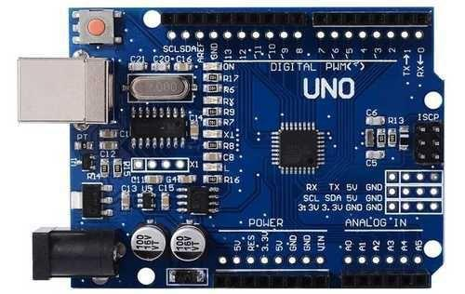

**Fig 3.1 Arduino Uno**

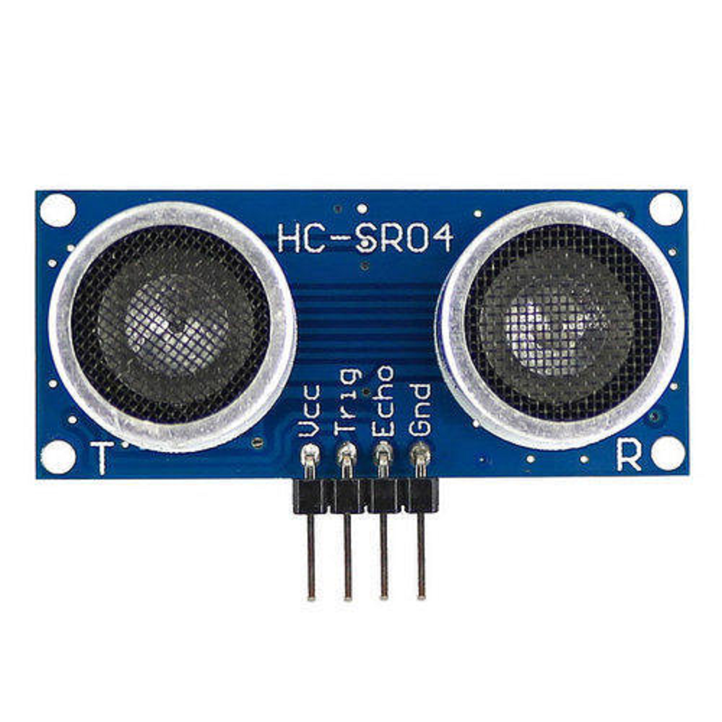

**Fig. 3.2 Ultrasonic Sensor**

**3.2 Writing Code for Sensor**

The hardware is connected to our computer and coding is done using the Arduino IDE to calculate the level of garbage inside the dustbin. Additionally, a threshold value is defined for sending alerts to the concerned authorities. Code for interfacing the WiFi module is also written at this stage.

**3.3 Creating Web App for displaying alerts**

A web app is created which is used to read alerts generated from the smart bin from either a cloud service or read locally and displays an appropriate message.

**3.4 Interfacing the web app and Arduino**

Data is either read from ThingSpeak API which is used for storing IoT data. It can also be done locally using a software called CoolTerm which writes the data read from the Arduino to a text file which can be read by the web app in real time.

**Chapter 4**

**Result and Discussion**

As soon as a garbage item enters the smart bin which makes the level of garbage go over the threshold limit, the Arduino reads this data and writes it locally on a file. The web app reads data from the file and notifies the user that the dustbin is full.

The garbage monitoring system can effectively monitor the garbage level and notify the user or concerned authority on bin overflowing.

**Chapter 5**

**Conclusion and Future Work**

The main objective of this system is to maintain a healthy and clean environment in our city around us. The smart garbage monitoring system can efficiently handle the problem of waste disposal by continuous monitoring such that no dustbin overflows and concerned authorities are notified to keep our city clean and hygienic.

In the future, many smart bins can be set up which use a GPS module such that the location of each of the bin can be tracked effectively and AI based algorithms can be used to decide the minimum distance path that waste management authorities can use to collect the data from different points in the city. Also a camera can be fit inside these smart bins along with a servo motor system which classifies the garbage into biodegradable and non-biodegradable and thus puts the garbage into their respective partitions in the smart bin.

**References**

[1] Mamatha Dhananjaya, Priyanka.K.E. E, Nidhi.R, Pooja.K- “Smart Garbage Monitoring System Using Node MCU” http://thegrenze.com/index.php?display=page&view=journalabstract&ab sid=324&id=9

[2] Prof. Dr. Sandeep M. Chaware, Shriram Dighe, Akshay Joshi, Namrata Bajare, Rohini Korke – “Smart Garbage Monitoring System using Internet of Things (IOT)” https://www.researchgate.net/publication/326432685_IoT_based_Garba ge_Monitoring_System

[3] Anitha A – “Garbage monitoring system using IoT” http://iopscience.iop.org/article/10.1088/1757-899X/263/4/042027

[4]Vishnupriya M, Mohana priyanka K. and Malar R – “Smart Garbage Monitoring and Segregation Process Using Arduino” http://ijewce.com/issue/Smart%20Garbage%20Monitoring%20and%20S egregation%20Process%20Using%20Arduino.pdf